Warragul North Primary School

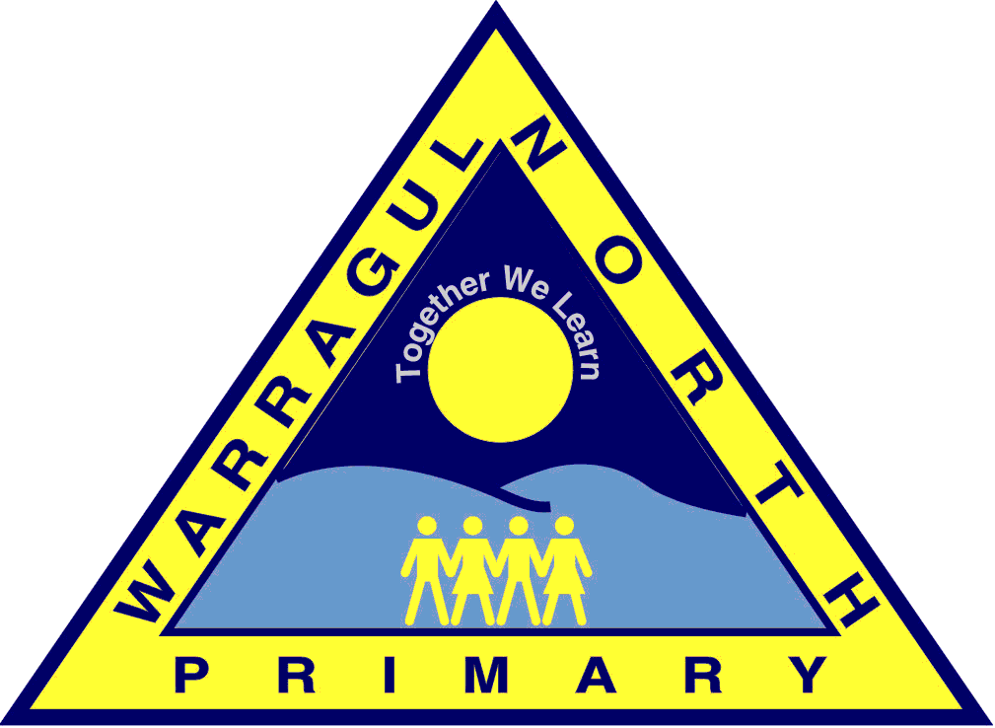
CHILD SAFE STANDARDS

CODE OF CONDUCT

POLICY

Rationale:

Warragul North Primary School is committed to the safety and wellbeing of children and young people. Our school community recognises the importance of, and a responsibility for, ensuring our school is a safe, supportive and enriching environment which respects and fosters the dignity and self-esteem of children and young people, and enables them to thrive in their learning and development.

This Code of Conduct aims to protect children and reduce any opportunities for child abuse or harm to occur. It also assists in understanding how to avoid or better manage risky behaviours and situations. It is intended to complement child protection legislation, Department policy, school policies and procedures and professional standards, codes or ethics as these apply to staff and other personnel.

The Principal and school leaders of Warragul North Primary School will support implementation and monitoring of the Code of Conduct, and will plan, implement and monitor arrangements to provide an inclusive, safe and orderly school and learning environment. The Principal and school leaders of Warragul North Primary School will also provide information and support to enable the Code of Conduct to operate effectively.

All staff, contractors, volunteers and any other member of the school community involved in child-related work are required to comply with the Code of Conduct by observing expectations for appropriate behaviour stated in this code of conduct. The Code of Conduct applies in all school situations, including school camps and in the use of digital technology and social media.

To promote child safety in the school environment we acknowledge the following:

All students have a right to:
- Take part in learning programs that meet their individual needs.
- Feel secure and to be safe in a caring and supportive environment.
- Work and play without interference in an atmosphere of harmony and cooperation.
- Receive respect, kindness and courtesy and to be treated with fairness.
- Have learning continued without disruption in a supportive environment.
- Be valued for their individuality including; race, gender, cultural, physical or intellectual diversity.
- Expect school rules to be fair, consistently implemented and respect the rights of all involved.
- To be safe in every aspect of daily life at school, including Out Of School Hours Programs, camps and excursions.

All students have a responsibility to:

- Care and value themselves, others, teachers and the school community.
- Be safety conscious in relation to themselves and others.
- Treat others with respect and good manners.
- Keep the guidelines of good behaviour, modelling and supporting school rules.
- Develop a sense of accountability for their own actions.
- Work to achieve their personal best whilst allowing others to do the same.
- Allow others to learn and to respect the rights of others.
- Explore their full potential in their learning.

School staff adheres to the following standards about the ways in which school staff are expected to behave with children:

- School staff provide opportunities for all students to learn
- School staff treat their students with courtesy and dignity
- School staff work within the limits of their professional expertise
- School staff maintain objectivity in their relationships with students
- School staff are always in a professional relationship with the students in their school whether at school or not

Acceptable behaviours
As staff, volunteers, contractors, and any other member of the school community involved in child-related work individually, we are responsible for supporting and promoting the safety of children by:
- upholding the school’s statement of commitment to child safety at all times and adhering to the school’s Child Safety Statement of commitment policy
- treating students and families in the school community with respect both within the school environment and outside the school environment as part of normal social and community activities.
- listening and responding to the views and concerns of students, particularly if they are telling you that they or another child has been abused or that they are worried about their safety/the safety of another child
- promoting the cultural safety, participation and empowerment of Aboriginal and Torres Strait Islander students
- promoting the cultural safety, participation and empowerment of students with culturally and/or linguistically diverse backgrounds
- promoting the safety, participation and empowerment of students with a disability
- reporting any allegations of child abuse or other child safety concerns to the school’s Principal Class officers or Child Safety Standards Officer
- understanding and complying with all reporting or disclosure obligations (including mandatory reporting) as they relate to protecting children from harm or abuse.
- if child abuse is suspected, ensuring as quickly as possible that the student(s) are safe and protected from harm.

Unacceptable behaviours
As staff, volunteers, contractors, and any other member of the school community involved in child-related work we must not:
- ignore or disregard any concerns, suspicions or disclosures of child abuse
- develop a relationship with any student that could be seen as favouritism or amount to ‘grooming’ behaviour (for example, offering gifts)
- exhibit behaviours or engage in activities with students which may be interpreted as abusive and not justified by the educational, therapeutic, or service delivery context
- ignore behaviours by other adults towards students when they appear to be overly familiar or inappropriate
- discuss content of an intimate nature, except where it occurs relevantly in the context of parental guidance, delivering the education curriculum or a therapeutic setting
- use sexual innuendo with students
- treat a child unfavourably because of their disability, age, gender, race, culture, vulnerability, sexuality or ethnicity.
- communicate directly with a student through personal or private contact channels (including by social media, email, instant messaging, texting etc) except where that communication is reasonable in all the circumstances, related to school work or extra-curricular activities or where there is a safety concern or other urgent matter
- photograph or video a child in a school environment except in accordance with school policy or where required for duty of care purposes
- in the school environment or at other school events where students are present, consume alcohol contrary to school policy or take illicit drugs under any circumstances.

Implementation:

Procedures for responding to and reporting allegations of suspected child abuse

Forming a belief on reasonable grounds
A person may form a belief on reasonable grounds that a child is in need of protection after becoming aware that a child or young person’s health, safety or wellbeing is at risk.

Reporting a belief

Mandated staff members (Teachers and Principals) must make a report to Child Protection as soon as practicable after forming a belief on reasonable grounds that a child or young person is in need of protection.

Staff members, whether or not mandated, need to report to the principal or assistant principal their belief when the belief is formed in the course of undertaking their professional duties.
A report must be made as soon as practicable after forming the belief and on each occasion on which they become aware of any further reasonable grounds for the belief.
If one staff member has a different view from another staff member about making a report and the staff member continues to hold the belief that a child is in need of protection, that person is obliged to make a report.

Please refer to the Mandatory Reporting Policy and Procedures Policy 2014 for procedures in response to allegations of child abuse.

These procedures do not:
- prohibit or discourage school staff from reporting an allegation of child abuse to a person external to the school;
- state or imply that it is the victim's responsibility to inform the police or other authorities of the allegation;
- require staff to make a judgment about the truth of the allegation of child abuse; or
- prohibit staff from making records in relation to an allegation or disclosure of child abuse.

Strategies to identify and reduce or remove risks of child abuse
Risk management strategies have been developed within the following school policies:
  - Mandatory Reporting Policy and Procedures Policy 2014
  - Student Engagement Policy 2014
  - Duty of Care Policy 2014
- Ensure that all staff are up to date with the DET’s Mandatory Reporting online Professional Development module.
- Ensure that we follow the staff selection checklist before any staff member is offered employment.
- Ensure that our Out of School Hours Care provider has a copy of our school policy.
- Provide a safe environment that staff can come and discuss their concerns regarding a child at risk, with the Principal.
- Provide students regularly with exposure to numbers such as Kids Helpline through the mechanism of our eSmart curriculum.

References:

http://www.education.vic.gov.au/school/principals/spag/safety/pages/dutyofcare.aspx

If the school identifies risks of child abuse occurring in one or more school environments the authority must make a record of those risks and specify the action(s) the school will take to reduce or remove the risks (risk controls).
Explanatory note: Different risk controls may be necessary for particular groups of children
depending on the nature of the risk and the diversity characteristics of children affected by the risk.
- As part of its risk management strategy and practices, the school must monitor and evaluate the effectiveness of the implementation of its risk controls.
- At least annually, the school must ensure that appropriate guidance and training is provided to the individual members of the school staff about:
  - individual and collective obligations and responsibilities for managing the risk of child abuse;
  - child abuse risks in the school environment; and
  - the school's current child safe standards.

Strategies to promote child empowerment and participation
- The school authority must develop strategies to deliver appropriate education about:
  - standards of behaviour for students attending the school;
  - healthy and respectful relationships (including sexuality);
  - resilience; and
  - child abuse awareness and prevention.
- The school must promote the child safe standards in ways that are readily accessible, easy to understand, and user-friendly to children.

Evaluation:
This policy will be reviewed annually in consultation with the whole school community as part of the school’s five-year review cycle.

This policy was ratified by School Council in August 2016 This policy was amended by School Council in July 2018 This policy was reviewed and amended by School Council on June 18th 2019

SPAG: http://www.education.vic.gov.au/school/principals/spag/safety/pages/photoandfilm.aspx . The policy says the school should get consent before taking and publishing photos of a student. This applies every time a photo is taken. The same policy applies for excursions and school activities.
SPAG: http://www.education.vic.gov.au/school/principals/spag/safety/pages/alcohol.aspx. The policy says the school must obtain school council approval before alcohol can be consumed on school grounds or at a school activity. The policy says staff members should not consume alcohol during camps and excursions. It is silent on whether they can consume alcohol at other school events where students are present, this is a matter that the school needs to decide upon – draft text is provided in the guidance fact sheet

